SpanTypeTextBase Example

A SpanTypeTextBase is a TextBase that is a subset of a parent TextBase containing only one spanType from the parent. For example, you may have a parent TextBase the contains several emails and wish to create a SpanTypeTextBase containing only the bodies of the those emails.

To create a SpanTypeTextBase, you must have the parent Labels and know the spanType you would like to extract.
SpanTypeTextBase childTB = new SpanTypeTextBase(parentLabels,spanType);

To import the labels from the parent TextBase you need to have the parent Labels:
TextLabels childLabels = childTB.importLabels(parentLabels);

Here is an example using the emails in on of the cspace databases and extracting their bodies. Here is a sample loader:

import edu.cmu.minorthird.text.*;

System.out.println("target labels: true_name, true_date");
System.out.println("target classes: meeting");

TextBaseLoader baseLoader = new TextBaseLoader(TextBaseLoader.DOC_PER_FILE, TextBaseLoader.FILE_NAME, true);
TextBase base = baseLoader.load(new File(dataDir,"cspace/9-7-97"));
MutableTextLabels labels = baseLoader.getLabels();
TextLabelsLoader labelsLoader = new TextLabelsLoader();
labelsLoader.setClosurePolicy(TextLabelsLoader.CLOSE_ALL_TYPES);
labelsLoader.importOps(labels, base, new File(labelDir,"cspace/9-7-97-names-corrected.env"));
labelsLoader.importOps(labels, base, new File(labelDir,"cspace/9-7-97-dates-corrected.env"));

SpanTypeTextBase childTB = new SpanTypeTextBase(labels,"body");
TextLabels childLabels = childTB.importLabels(labels);
return childLabels;

As you can see, the loader is the same as the original cspace.07 loader, but it contains the two extra lines to create the SpanTypeTextBase.

Once you have created a loader, see if it works by Viewing the Labels:
% java –Xmx500M edu.cmu.minorthird.ui.ViewLabels –labels cspace-SpanTypeTB

A window like this should appear:
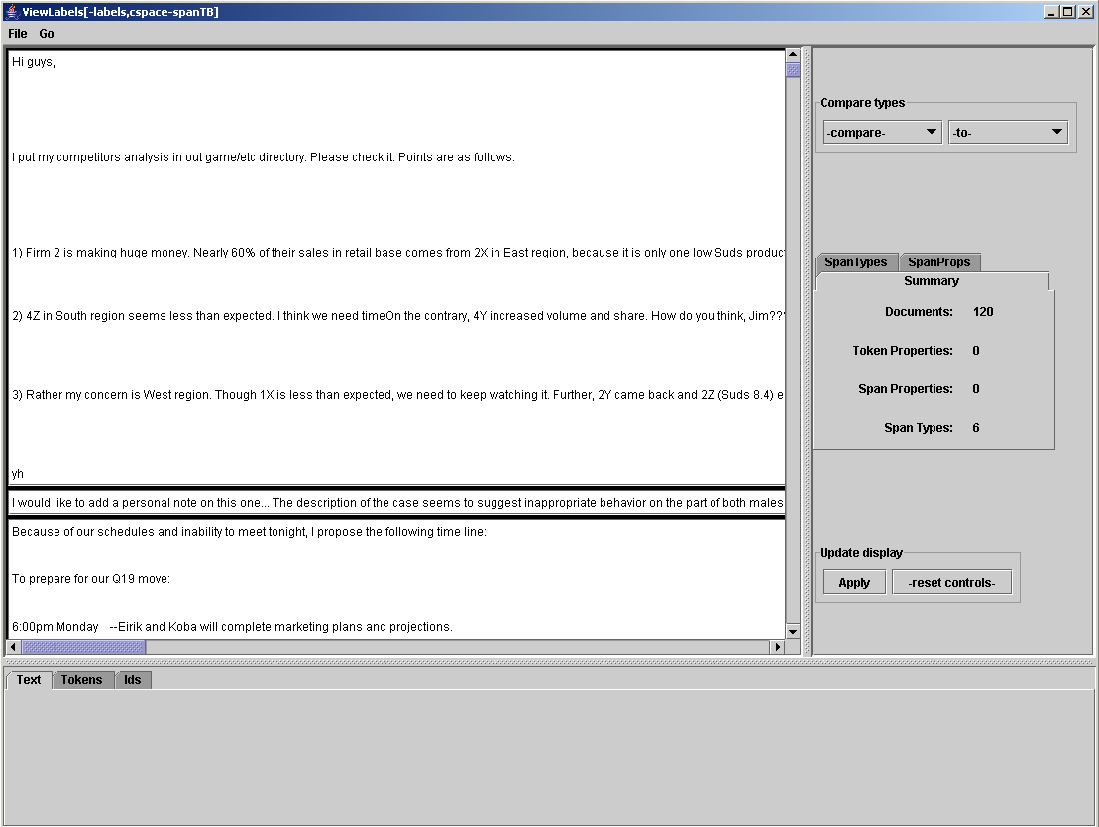

Notice: there should be no email headers or signatures. There should be only 6 spanTypes since the remaining spanTypes are not inside the body of the email.

Check to see if the spanTypes were imported properly by highlighting the true_name spanType:

